Selenium Grid

**Selenium-Grid support distributed test execution**

**What is selenium Grid:**

Selenium-Grid allows you run your tests on different machines against different browsers in parallel.

**Why Selenium Grid:**

To run the test against

* + Multiple browsers and versions.
  + Multiple runtime environments
  + Multiple operating systems.

To reduce the test suite run time

**HUB & NODE :**

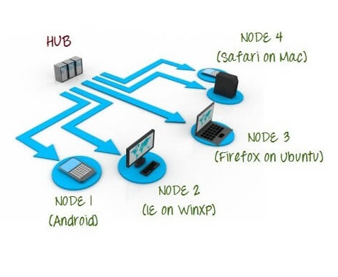

**HUB**

* Is a central point where you load test
* Only one HUB in Grid
* On HUB the test will be run

**NODE**

* It executes the tests that you loaded on the HUB
* Multiple NODEs in Grid
* NODEs can be on multiple machine with different platform and browser.

**Setting up Selenium Grid:**

* Step 1 - Download Selenium Standalone server <http://www.seleniumhq.org/download/>
* Step 2 - Launch the HUB

**java -jar selenium-server-standalone-2.30.0.jar -role hub**

* Step 3 - Verify HUB is up and running
* Step 4 - Launch the NODE

**java -jar selenium-server-standalone-2.30.0.jar -role webdriver hub**

[**http://192.168.1.2:4444/grid/register**](http://192.168.1.2:4444/grid/register) **-port 5566**

**Grid Objects:**

To design test scripts that will run on the grid, we need to use **DesiredCapabilites** and the **RemoteWebDriver** objects.

**DesiredCapabilites**is used to set the type of **browser** and **OS**that we will automate

**RemoteWebDriver**is used to set which node (or machine) that our test will run against.

**Sample Script:**

**public** **class** Demo_Grid1 {

**static** String *driverPath* = "C:\\Selenium Lib\\";

**public** **static** **void** main(String[] args) **throws** MalformedURLException {

System.*setProperty*("webdriver.chrome.driver",*driverPath*+"chromedriver.exe");

DesiredCapabilities capability = DesiredCapabilities.*chrome*();

capability.setBrowserName("chrome");

capability.setPlatform(Platform.***ANY***);

WebDriver driver = **new** RemoteWebDriver(**new** URL("http://localhost:4444/wd/hub"), capability);

**try** {

driver.get("http://demo.opencart.com/");

driver.manage().window().maximize();

System.***out***.println(driver.getTitle());

}

**catch**(Exception ex){

System.***out***.println("Hello");

}

}

}